Ancient Greek Theatre

- First recorded form of European theatre - 600 B.C.
- First play made to honor the God Dionysus (Di-on-i-sus)
  - This play was written by Thespis, which is why actors are sometimes called Thespians!
- 3 types of plays:
  - Tragedies always had a sad ending - actors wore dark colors
  - Comedies always had a happy ending - actors wore bright colors
  - Satires poked fun at real people and events.
- Famous playwright: Sophocles (wrote 120 plays, including Oedipus)
- Crowds of around 15,000 people per performance!
- Almost every town had a theatre
- Theatres were outside, in a semi-circle on a hillside
- All the actors wore masks at all times
  - Masks were designed to show age, gender, and emotion
  - Masks had large mouth holes to make their voices louder.
- All the actors were men

Activity: Watch video clips of tragedies, comedies, and satires! (Miranda Sings, Romeo and Juliet, and That’s So Raven)
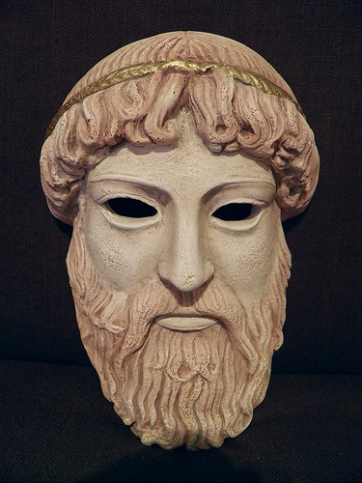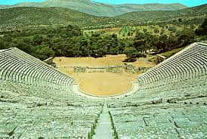
Ancient Greek Mask Ancient Greek Theatre
(old sad man)

WILLIAM SHAKESPEARE

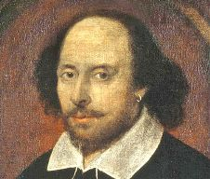

Early Life
Very little is known about William Shakespeare's childhood. He was born in the English city of Stratford-upon-Avon about 100 miles northwest of London in 1564. William's father was a successful leather merchant who once held the public position of alderman. He was the third of six children including two older sisters and three younger brothers.
Growing up in Stratford-upon-Avon William lived in a house with his family on Henley Street. He went to the local grammar school where he learned about poetry, history, Greek, and Latin.
When William turned eighteen he married Anne Hathaway. They soon had a family including a daughter named Susanna and twins named Hamnet and Judith.

London and the Lost Years
After William and Anne had the twins, there are no records of the next several years of his life. Historians often refer to these years as the "lost years." There are lots of theories and stories about what William was doing during this time. In any event, he and his family eventually ended up in London where William was working at the theatre.

Lord Chamberlain's Men
William was part of an acting company called Lord Chamberlain's Men. An acting company in England at this time worked together to put on plays. There were typically around ten actors in a company including a lead actor, character actors, and some comedians. Young boys typically played women's roles as women were not allowed to act.

Early Plays
Shakespeare wrote plays for the Lord Chamberlain's Men. He worked as an actor as well. His plays became very popular in London and soon the Lord Chamberlain's Men were one of the most popular acting companies in the city. Some of Shakespeare's early plays include The Taming of the Shrew, Richard III, Romeo and Juliet, and A Midsummer Night's Dream.

The Theater Shuts Down
These early plays were put on at a theater called the "Theatre". While Lord Chamberlain's Men owned the Theatre, the land was owned by Giles Allen. In 1597 Allen decided he wanted to tear the Theatre down. He locked it up and refused to let the actors perform. They tried to renegotiate the lease on the land, but Allen again refused.

One night, several members of the company dismantled the Theatre and moved the timber across the Thames River to another spot. There they built a new theatre called the Globe Theatre.

The Globe Theatre
The Globe Theatre became the place to be in London. It could house up to 3,000 spectators and had a uniquely designed stage with a painted ceiling, columns, and stage wall. They had specially trained musicians who made special effects noises during the plays. They even had a cannon that fired blanks.

Later Plays
Many of Shakespeare's greatest plays were written in the last half of his career. These included Hamlet, Othello, King Lear, and Macbeth. He was a wealthy man and purchased a large home in Stratford for his family called New Place.

Poetry
Shakespeare also was famous for his poetry. His most famous poem of the time was Venus and Adonis. He wrote poems called sonnets. A book of 154 of them was published in 1609.

Death
William retired to his home in Stratford and died on his fifty-second birthday.

Legacy
Shakespeare is considered by many to be the greatest writer of the English language. He is also one of the most influential. Through his works, he is credited with introducing nearly 3,000 words to the English language. In addition, his works are the second most often quoted after the Bible.

Interesting Facts about William Shakespeare
- The lead actor and star of many of Shakespeare's plays was Richard Burbage.
- The original Globe Theatre burned down in 1613. It was rebuilt in 1614, but was then closed in 1642.
- A modern reconstruction of the Globe was built in London by American actor Sam Wanamaker. It opened in 1997.
- He wrote 37 plays in his lifetime averaging about 1.5 plays per year he was writing. Some scholars think that he wrote around 20 more plays that have been lost, which would put the total to 57!
- His plays were performed for both Queen Elizabeth I and King James I.
- You can take the letters from "William Shakespeare" and write "I am a weakish speller.

(Our favorite) WORDS SHAKESPEARE INVENTED:
-addiction -champion -amazement -countless -exposure -rant -outbreak -olympian -bandit -lower
-assassination -excitement -dawn -unreal -mimic -hint -generous -gloomy -bump -blanket
-bedroom -gossip -fixture -label -luggage -fashionable -majestic -lonely -jaded -moonbeam -zany

ACTIVITY:
- Be like Shakespeare and make up your own word and write out the definition, and an example sentence of how it could be use. Feel free the draw and write in colors around the definition.
- Shakespeare wrote parts of his plays with poems. Try to write a poem about your life. If you are up for a challenge, make it rhyme every other line. Here is an example poem:
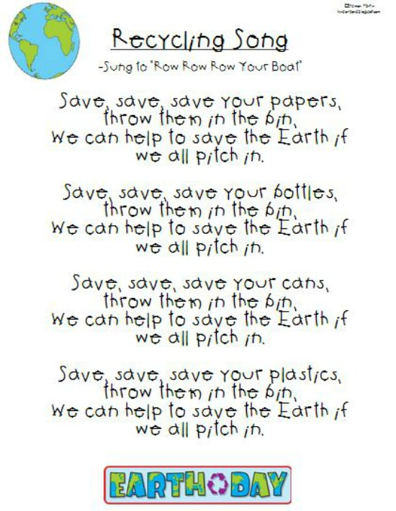

JAPANESE KABUKI THEATRE

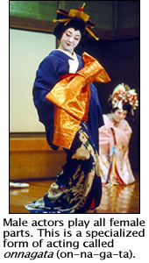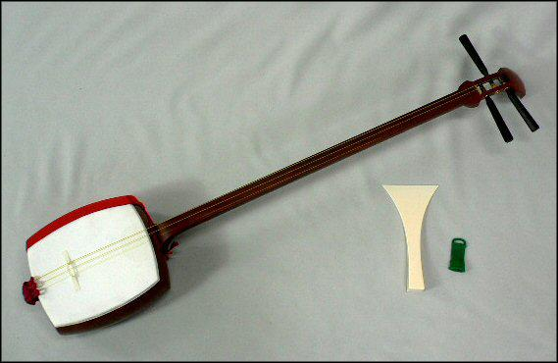

Kabuki (ka-bu-ki) is a form of theater in Japan that began in the early 1600s and is still performed today. This traditional theater uses extravagant makeup and costumes, a unique kind of music and an all-male cast.

- A woman named Okuni (O-kun-i) created Kabuki Theater, but shortly after it became popular women were banned from performing.

- The plays were based on Japanese legends and would open and close with the sound of wood clapping together.

- The style of music in Kabuki Theater is named for a three-stringed instrument called a shamisen (sham-i-sen). The music enhances the actors’ movements and voices, making them almost like dancing and singing.
- During the climax in the play or at the end of a scene, the actor freezes in place, stares and then crosses his eyes. This is called mie (mi-e) .
- Each Kabuki character wears colorful costumes and has thick makeup that looks like a mask. The color red on a character’s face signifies a “good” character and blue suggests a “bad” character.

All of these elements have made Kabuki Theater a traditional art form that has entertained audiences for over 400 years.

ACTIVITY:
Create your own Kabuki mask! Use the pictures below for inspiration!
